IHE-Europe
Blvd. A. Reyers 80
B-1030 Brussels
secretariat@ihe-europe.net

Agreement on Exclusive Services in the IHE-Europe Connectathon week

IHE-Europe Experience Days – Sponsorship Packages |  | Price in Euros
 | 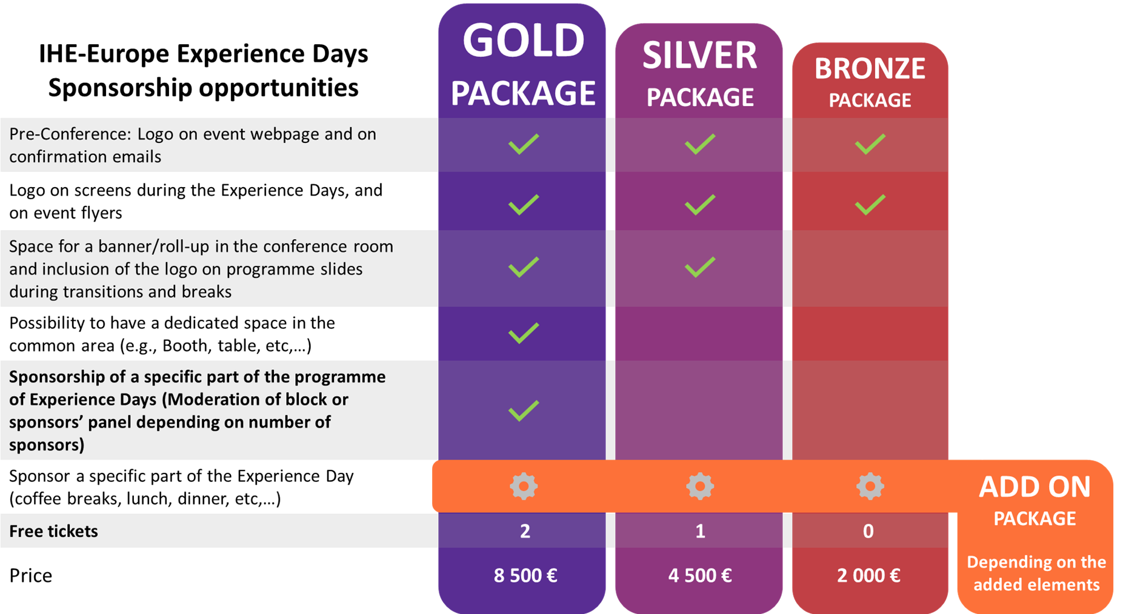
 | Gold (up to 2) | 8,500.-
 | Silver (up to 4) | 4,500.-
 | Bronze (up to 6) | 2,000.-

IHE-Europe will send the invoice of the package fee to the sponsor once they have submitted the signed sponsorship contract.
All amounts are exclusive of Belgian VAT (21%).

Brussels, 2023 | Date
IHE-Europe | Institution/Company
Blvd. A. Reyers 80 | Street
B-1030 Brussels | ZIP/City
 |  | Binding order of the services marked above
IHE-Europe Marketing and Communications Committee jointly with the IHE-Europe Experience Days taskforce |  | Authorised signatory

